**Technical Report: Barclays Bank Customer Churn Analysis (2024)**

1. Introduction

This report provides a data-driven analysis of customer churn at Barclays Bank using a combination of demographic, behavioral, and financial variables. The main objective is to uncover trends, risks, and opportunities that can help reduce customer churn and improve retention efforts.

2. Story of Data

The dataset used for this analysis contains 10,000 customer records from Barclays Bank. It captures key attributes such as age, gender, location, credit score, account balance, tenure, product usage, and customer activity status. The goal is to understand which of these factors contribute to customers exiting the bank. The target variable is Exited, indicating whether a customer left (1) or stayed (0).

3. Pre-Analysis

In the preparation phase:

* Data was cleaned to ensure consistency.
* Columns were reviewed and categorized into independent and dependent variables.
* Key metrics such as churn rate, balance distribution, and demographic breakdowns were identified.
* Initial visuals were designed to get a sense of customer segments at risk.

4. In-Analysis

During detailed analysis:

* Customers aged 30–45 had the highest churn count.
* Female customers churned more than male customers.
* Inactive accounts had a significantly higher churn rate.
* Customers with higher balances were also leaving, indicating loss of high-value clients.
* Germany stood out as the country with the highest total churned balance.

These patterns were visualized using bar charts, donut charts, and KPIs in the Power BI dashboard.

5. Post-Analysis and Insights

After exploring the dashboard, we discovered:

* A mismatch between product engagement and retention. Many churners used fewer products.
* Poor engagement was the most common trait among churners.
* Country-specific churn patterns show regional issues, particularly in Germany.
* A small group of high-value customers account for a large share of the churned balance.

6. Recommendations and Observations

Recommendations:

* Create retention programs targeting females aged 30-45.
* Launch engagement campaigns focused on inactive members.
* Assign relationship managers to clients with high balances.
* Investigate customer experience in Germany for service gaps.

Observations:

* Churn is not evenly spread—it’s concentrated in a few key segments.
* Inactivity is a strong early warning signal.
* High churn among premium clients poses a serious business risk.

7. Visualization

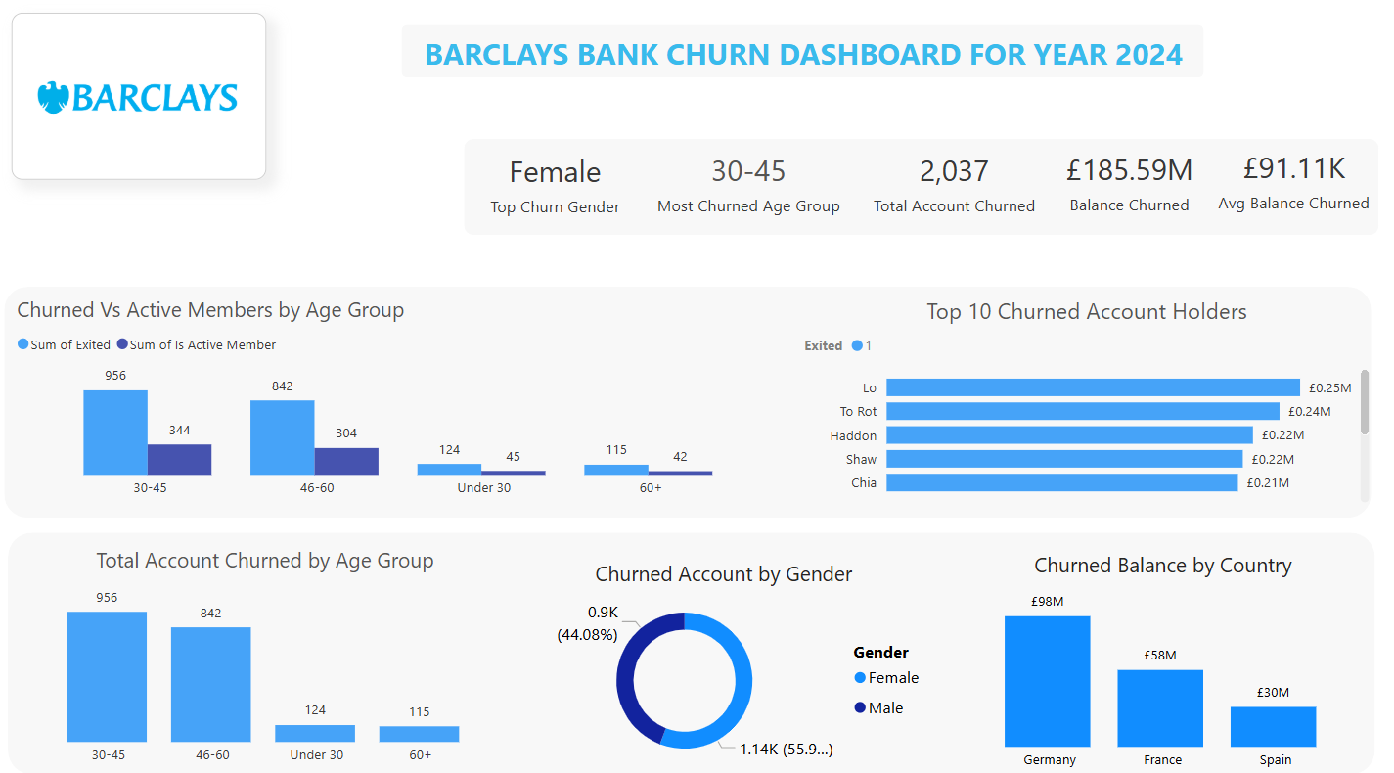

8. Conclusion

This project shows that churn can be predicted and prevented with the right insights. Barclays is currently losing its most valuable customers not just in volume but also in financial worth. By focusing on engagement, personalization, and region-specific solutions, the dashboard is clean, informative, and easy to understand. Future improvements could include interactive filters (e.g., by country, tenure) and time-based trends for more dynamic storytelling.